HOYSALA COLLEGE OF MANAGEMENT SHIVAMOGGA
SPORTS DAY EVENTS

ADDRESSING THE STUDENTS BY OUR COLLEGE TEAM

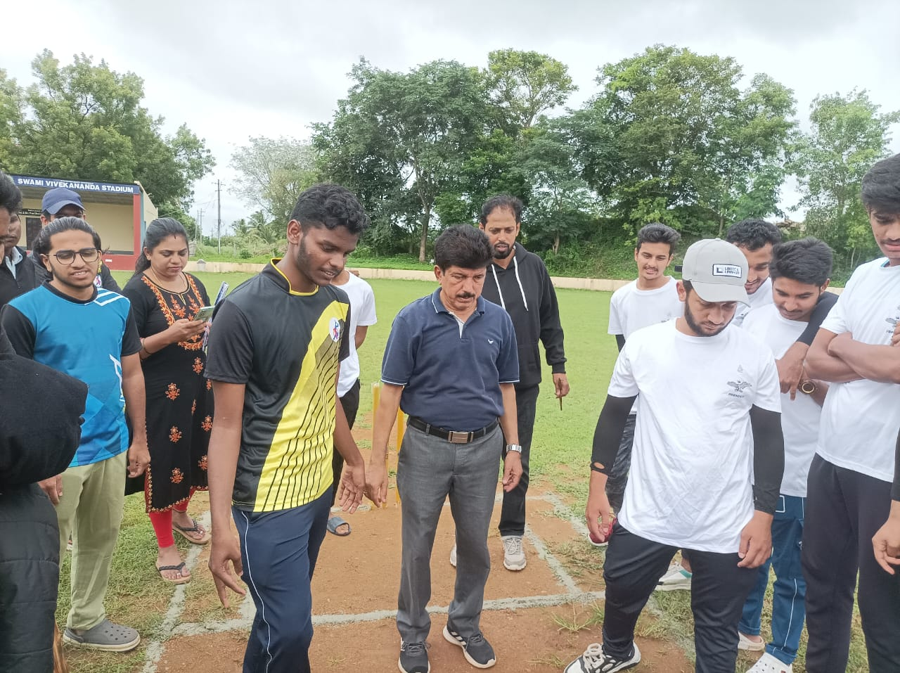
GROUP PHOTO WITH COLLEGE PRINCIPAL, MANAGEMENT AND STUDENTS WITH FACULTIES.

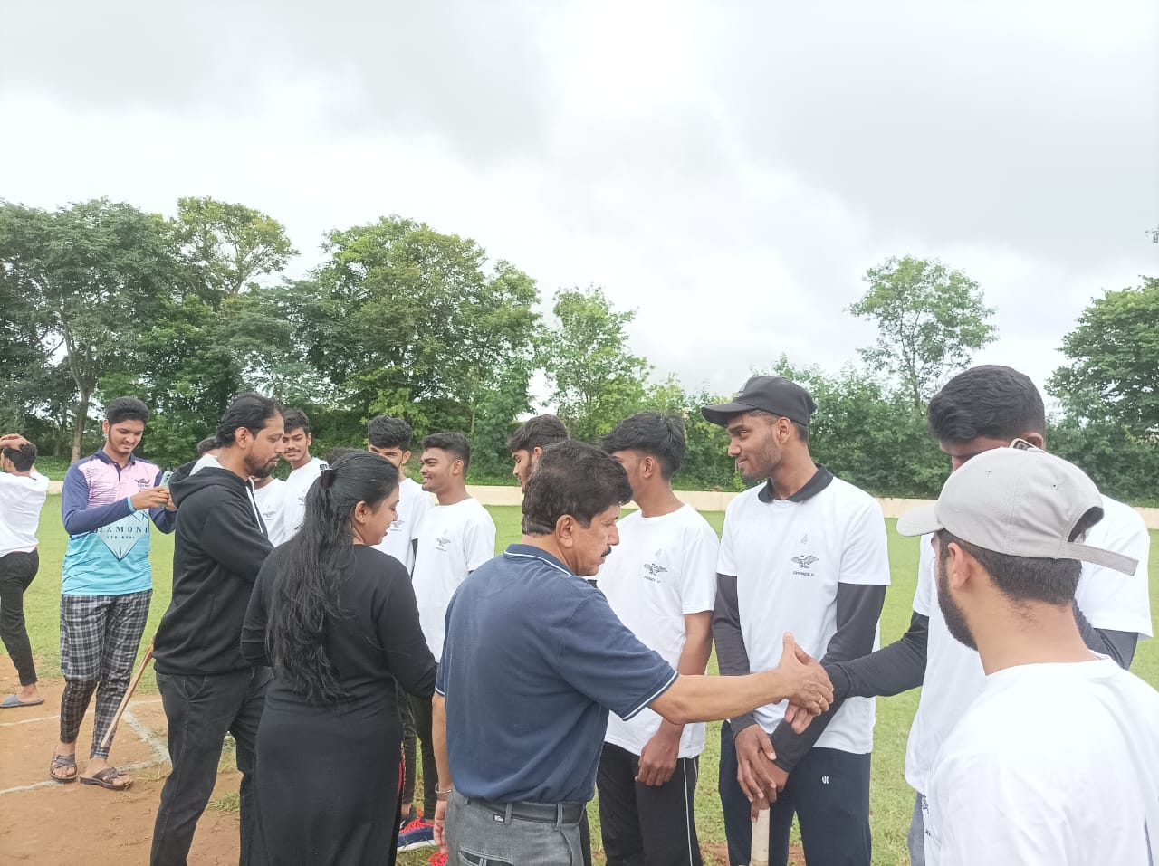

INTRODUCTION OF TEAM MEMEBRS

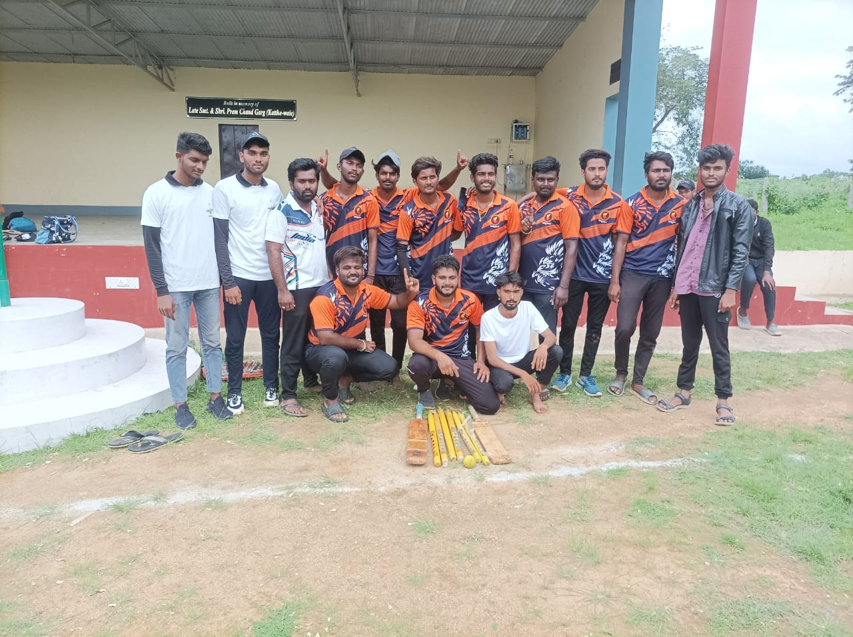

CRICKET WINNERS

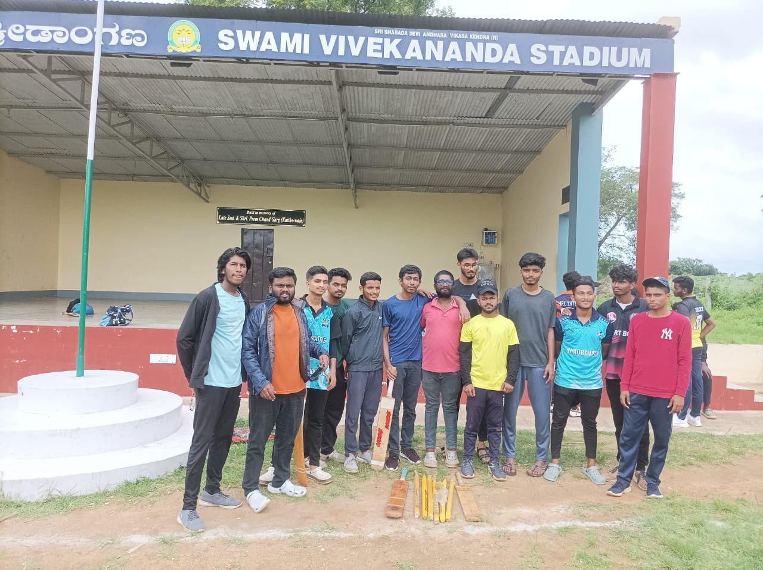

CRICKET RUNNERS

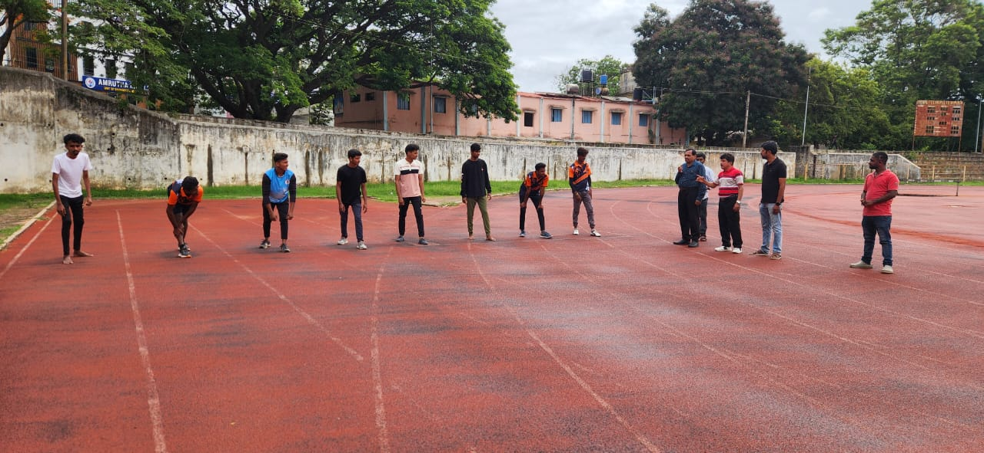
TRACK EVENTS

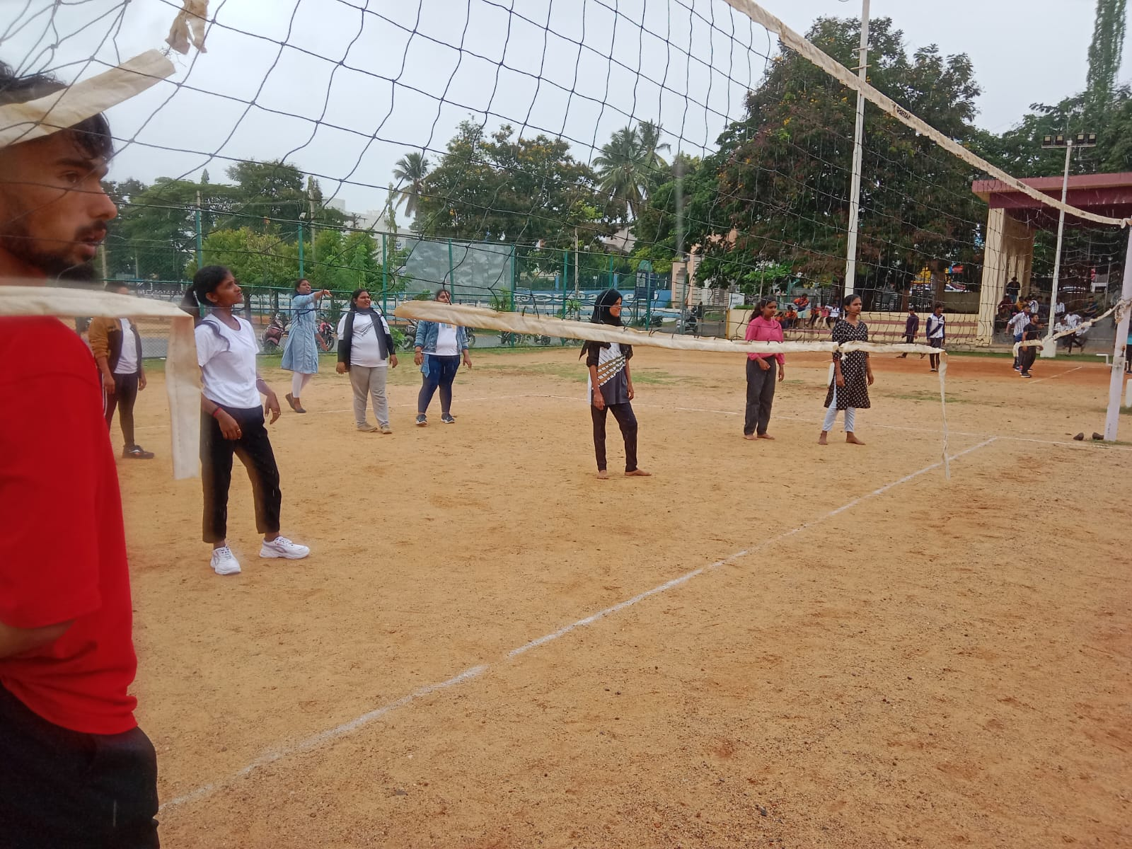
THROW BALL EVENT

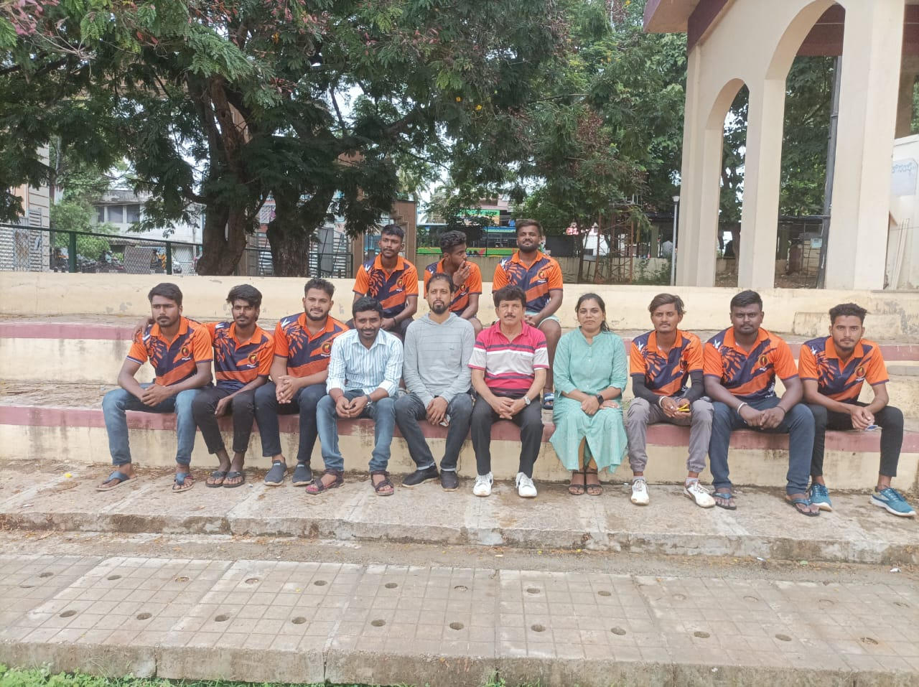
VOLLEY BALL WINNERS 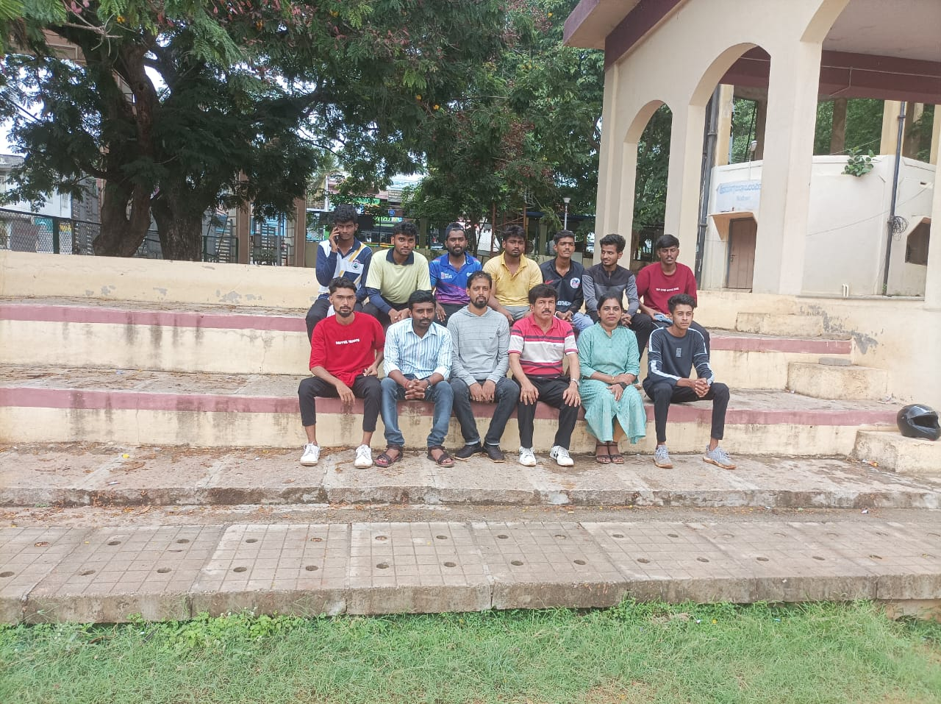
VOLLEY BALL RUNNERS

